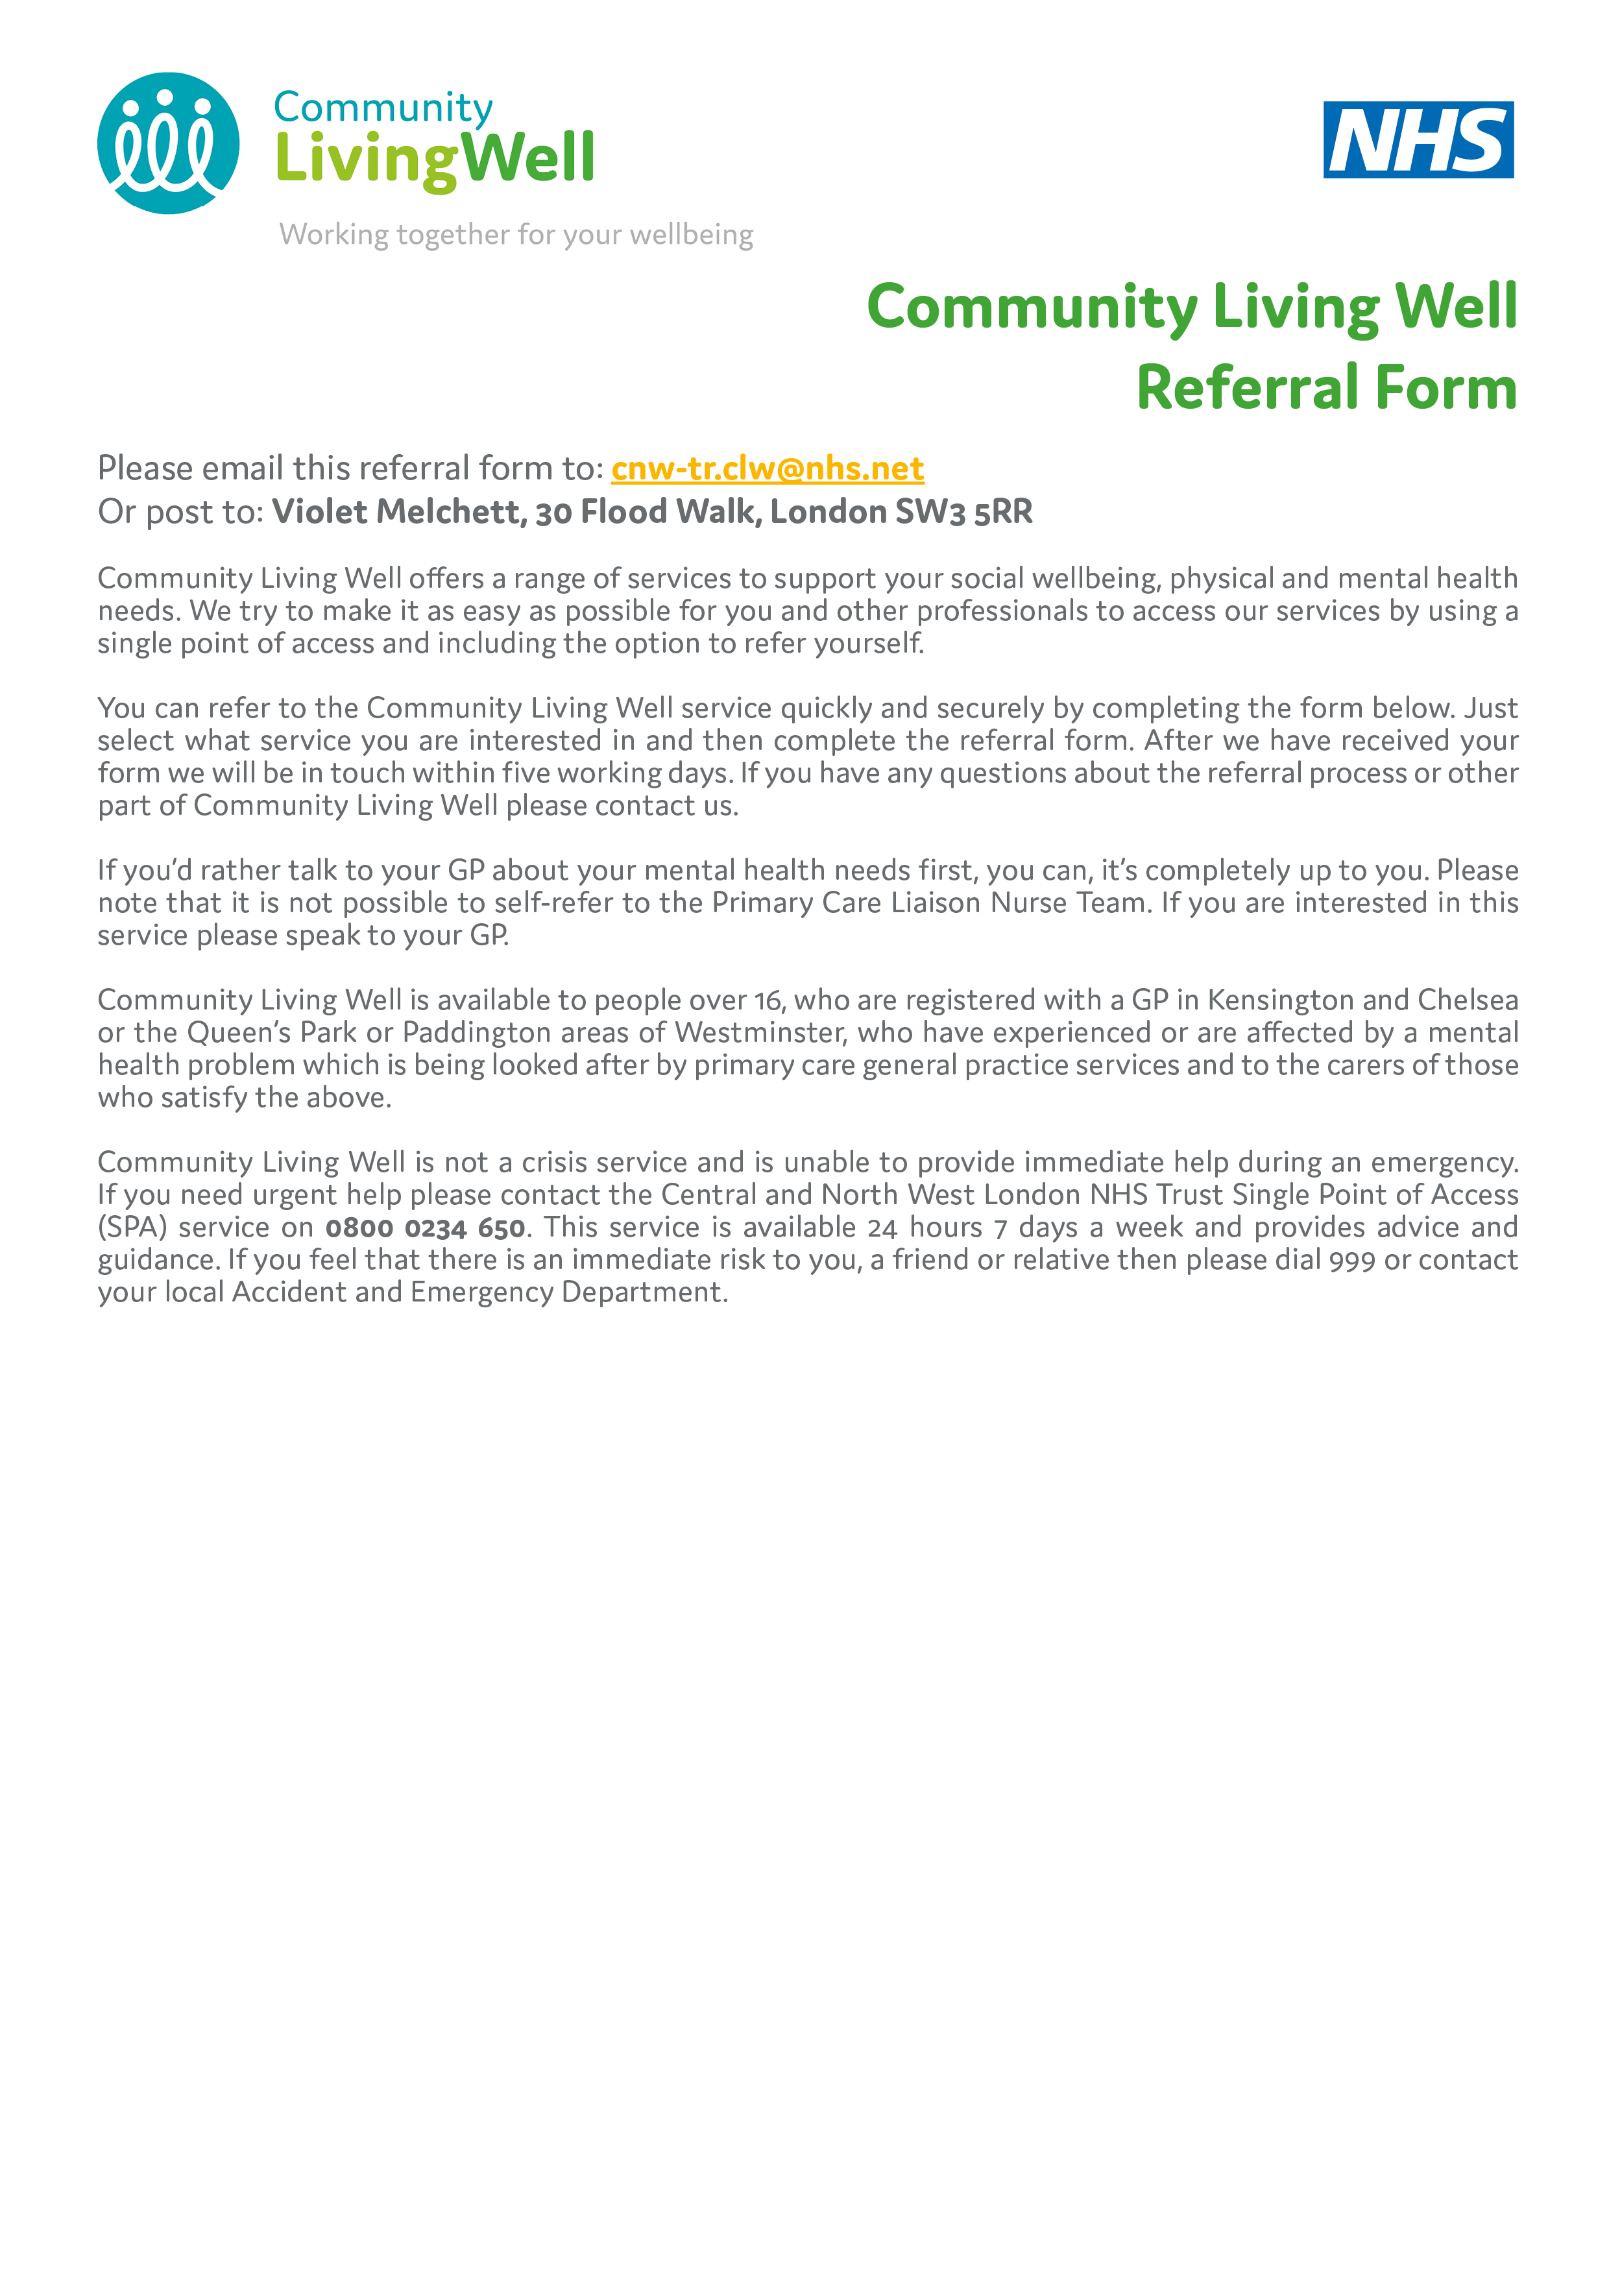

WHICH COMMUNITY LIVING WELL SERVICE WOULD YOU LIKE TO REFER YOURSELF TO?
☐ | Employment | Support to gain or retain paid employment, and improve employability skills through volunteering, training or education.
☐ | Navigators | Practical support with a range of issues including benefits, debt, housing options, access to health and social care services and support to access specialist advice and information.
☐ | Peer Support | A range of group and one-to-one support to improve social, emotional, and practical skills and resilience, by people with lived experience.
☐ | Self-Care | Support and activities that help you to take control of your mental, physical and emotional wellbeing.

To refer yourself to Talking Therapies please complete the following online form: http://bit.ly/2CTNYnk. To be referred to a Primary Care Liaison Nurse you must speak to your GP.

DETAILS ABOUT YOU
First Name:
Last Name:
Date of Birth: | D | D |  | / |  |  | M | M |  | / |  | Y | Y |  | Y |  | Y
What best describes your gender? | ☐ Female
 | ☐ Male
 | ☐ Prefer not to say
 | ☐ Prefer to self-describe:
Email address:
Can we email you?: | ☐ Yes |  |  |  | ☐ No
Address:
POSTCODE:
Can we write to you at your address?: | ☐ Yes |  |  |  | ☐ No
Telephone No:
Can we leave a message on your phone?: | ☐ Yes |  |  |  | ☐ No
Please tell us the best way to contact you
Do you require a translator or counselling in another language? | ☐ Yes |  |  |  | ☐ No
If yes, what language?
GP Practice
GP Name
Please briefly explain your difficulties and if there is a part of the Community Living Well service you are most interested in. For Self-Care services, please select two services you would like to refer to.

